**INDIAN INSTITUTE OF TECHNOLOGY PATNA**

**MECHANICAL ENGINEERING DEPARTMENT**

**BTech Project Allotment Form**

**Subject: Project – I, II (ME 495, ME496)**

I/We are assigned under Dr. Subrata Kumar for Btech Project here by undertake to carry the work sincerely. We also undertake to abide the academic rules framed by Department of Mechanical Engineering, IIT Patna.

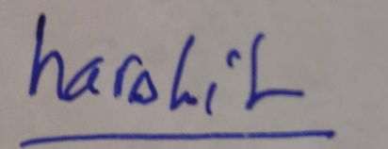 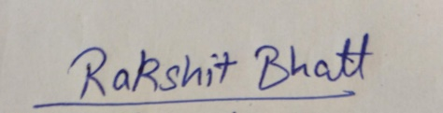

Name: Harshit Singh Name : Rakshit Bhatt

Roll No: 1701ME18 Roll No : 1701ME30

Title of Btech Project: App for finding surface tension

Sign by BTP Supervisor

*(To be submitted before 06 July 2020)*